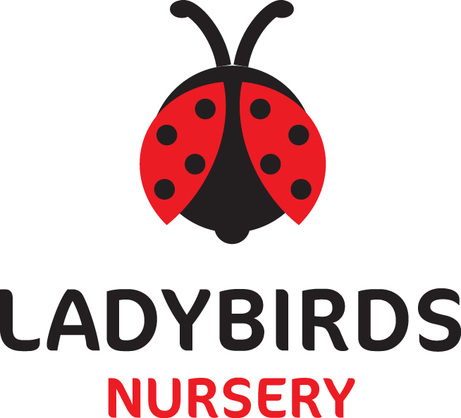

Managing children with allergies, or who are sick or infectious
(Including reporting notifiable diseases)

Promoting health and hygiene

Policy statement

We provide care for healthy children and promote health through identifying allergies and preventing contact with allergenic substances and through preventing cross infection of viruses and bacterial infections.

Procedures for children with allergies

When parents start their child at the nursery they are asked if their child suffers from any known allergies. This is recorded on the registration form.
If the child has an allergy, a risk assessment form is completed to detail the following
- The allergen (i.e. the substance, material or living creature the child is allergic to such as nuts, bee stings, eggs, etc.)
- The nature of the allergic reaction e.g. anaphylactic shock reaction, including rash, reddening of skin, swelling, breathing problems etc.
- What to do in case of allergic reactions, any medication used and how it is to be used (e.g. Epipen)
- Control measures- such as how the child can be prevented from contact with the allergen.

Review

- This form is kept in the child’s personal file and a copy is displayed where staff can see it, on the inside of the cupboard door that is not kept locked. This is so that staff can access the information easily, but the child’s dignity is being taken into account and we are not displaying their personal information for parents and visitors to see.
- Parents/professionals train staff in how to administer special medication in the event of an allergic reaction.
- Generally no nuts or nut products are used within the nursery
- Parents are made aware so that no nut or nut products are accidently brought in, for example for a party.

Insurance requirements for children with allergies and disabilities

- The insurance will automatically include children with any disability or allergy but certain procedures must be strictly adhered to as set out below. For children suffering life threatening conditions, or requiring invasive treatments, written confirmation from your insurance provider must be obtained to extend the insurance.

At all times the administration of medication must be compliant with the Welfare Requirements of the Early Years foundation Stage and follow procedures based on advice given in Managing Medicines in schools and Early years Settings (DfES 2005)

Oral medication

Asthma inhalers are now regarded as “oral medication” by insurers and so documents do not need to be forwarded to your insurance provider. Inhalers can be regarded as a life saving piece of equipment, for easy access we keep these in the rooms of the children who need them. They are stored where no child can access them but are accessible for staff. A risk assessment will be carried out before storing this medication in any room.
Risk assessment will be carried out for this procedure should any child attending need an inhaler.

- Oral medications must be prescribed by a GP and have manufacturers instructions clearly written on them.
- The staff must be provided with clear written instructions on how to administer such medication.
- All risk assessment procedures need to be adhered to for the correct storage and administration of the medication.
- The staff must have the parent or guardian’s prior written consent. This consent must be kept on file. It is not necessary to forward copy documents to your insurance provider.

Life saving medication & invasive treatment

Adrenaline injections (Epipens) for anaphylactic shock reactions caused by allergies to nuts, eggs etc) or invasive treatments such as rectal administration of Diazepam (for epilepsy).

The setting must have:

- A letter from the child’s GP/consultant stating the child’s condition and what medication if any is to be administered.
- Written consent from the parent or guardian allowing staff to administer medication
- Proof of training in the administration of such medication by the child’s GP, a district nurse, children’s nurse specialist or a community paediatric nurse.
- Staff will attend training before being allowed to administer any of this medication. At least 2 members of staff should attend this training. Both the manager and deputies should also attend if in the instance the staff member is not on duty.

Key person for special needs children - children requiring help with tubes to help them with everyday living e.g. breathing apparatus, to take nourishment, colostomy bags etc.

- Prior written consent from the child’s parent or guardian to give treatment and/or medication prescribed by the child’s GP.
- Key person to have the relevant medical training/experience, which may include those who have received appropriate instructions from parents/guardians, or who have qualifications.

Procedures for children who are sick or infectious

- If children appear unwell during the day – have a temperature, sickness, diarrhoea or pains particularly in the head or stomach – the manager/deputy/team leader calls the parents and asks them to collect the child, or send a known carer to collect the child on their behalf.
- If a child has a temperature, they are kept cool, by removing top clothing, sponging their heads with cool water, but kept away from draughts.
- Temperature is taken using a thermometer kept on top of the medicine cabinet.
- In extreme cases of emergency, the child should be taken to the nearest hospital and the parent informed.
- The nursery can refuse admittance to children who have a temperature, sickness and diarrhoea or a contagious infection or disease.
- Where children have been prescribed antibiotics, parents are asked to keep them at home for 48 hours before returning to nursery.
- After diarrhoea and sickness parents are asked to keep children at home for 48 hours or until a formed stool is passed.
- The setting has a list of excludable diseases and the current exclusion times.
- If a child or adult is diagnosed as suffering from a notifiable disease under the Public Health (infectious diseases) Regulations 1988, the GP will report this to the Health Protection Agency
- When the setting becomes aware, or is formally informed of the notifiable disease, the manager will inform Ofsted and act on any advice given by the Health Protection Agency.

HIV/AIDS/Hepatitis procedure

- HIV virus, like other viruses such as Hepatitis, (A,B,C) are spread through body fluids. Hygiene procedures for dealing with body fluids are the same for all children and adults.
- Single use vinyl gloves and aprons are worn when changing children’s nappies, pants and clothing that are soiled with blood, urine, faeces or vomit.
- Protective rubber gloves are used for cleaning/sluicing clothing after changing.
- Soiled clothing is rinsed and either bagged for parents to collect or laundered in the nursery.
- Spills of blood, urine, faeces or vomit are cleared using mild disinfectant solution and mops; cloths used are disposed of with the clinical waste.
- Tables and other furniture, furnishings or toys affected by blood, urine, faeces or vomit are cleaned using a disinfectant.
- Children do not share tooth brushes which are also soaked weekly in sterilising solution.

Nits and head lice

- Nits and head lice are not an excludable condition, although in exceptional cases a parent may be asked to keep the child away until the infestation has cleared.
- On identifying cases of head lice, all parents are informed and asked to treat their child and all the family if they are found to have head lice.

Policy Issued January 2016
Review Date January 2017
Date Reviewed May 2017
Review Date May 2018
Review Date

